Assessing the Impacts of Environmental and Ecological variables on the Performance of Fraser Sockeye Salmon Forecast

Yi Xu1, Qi Liu2, Caihong Fu1, John Holmes1

1 Fisheries and Oceans Canada, Pacific Biological Station, 3190 Hammond Bay Road, Nanaimo, BC, Canada

2 Fisheries and Oceans Canada, Pacific Region Head Office, 401 Burrard Street, Vancouver, BC, Canada

Corresponding author:

Yi Xu

Email : [Yi.Xu2@dfo-mpo.gc.ca](mailto:Yi.Xu2@dfo-mpo.gc.ca); [xuyiouqd@gmail.com](mailto:xuyiouqd@gmail.com); ORCIDs:

<https://orcid.org/0000-0002-9902-9588>

Supplementary materials

Table S1. Naïve models and their model descriptions.

| LLY | Return from the previous year;, where *Rett-1*is the observed return during the previous year (t-1) |
| --- | --- |
| R1C | Return from 4 years before the forecast year; , where *Rett-4* is the observed return four years prior to the forecasted return |
| R2C | Geometric mean return from 4 and 8 years before the forecast year; , where *Rett-4* and *Rett-8*are the observed returns four and eight years prior to the forecasted return |
| RAC | Geometric mean return on the forecast cycle line for all years;  , where *t-x* is the first cycle-line year with return data, and n is the number of cycle-line years with return data |
| TSA | Geometric mean return across all years;, where *N* is the number of years with return data |
| RS1 | Product of average survival from 4 years before the forecast year and the forecast brood year EFS; , where *Rt-4*is the recruits resulting from the EFS(*efft-4*) in the brood year four years prior to most recent brood year |
| RS2 | Product of average survival from 4 and 8 years before the forecast year and the forecast brood year EFS; , where *Rt-4*and *Rt-8* are the recruits resulting from the previous two cycle-line brood years (4 & 8 years prior to most recent brood year), and efft-4 and efft-8 are the number of EFS in the previous two cycle-line brood years |
| RS4yr | Product of average survival from the last 4 consecutive years and the forecast brood year EFS; , where *Rt* are the recruits (3, 4, and 5 year old fish) resulting from spawners in the brood year |
| RS8yr | Product of average survival from the last consecutive 8 years and the forecast brood year EFS , where *Rt* are the recruits (3, 4, and 5 year old fish) resulting from spawners in the brood year |
| MRS | Product of average survival for all years and the forecast brood year EFS; , where *Rt* are the recruits (3, 4, and 5 year old fish) resulting from spawners in the brood year and *N* is the number of years with data |
| RSC | Product of average cycle-line survival (entire time series) and the forecast brood year EFS; where *t-x* is the first cycle-line year with data, and *n* is the number of cycle-line years with data. |

Table S2. Summary of 2021 and 2022 sockeye runs

|  |  |  |  |  |  |  |
| --- | --- | --- | --- | --- | --- | --- |
|  | 2021 | | | 2022 | | |
| Forecast Return | Observed Return | (Observed-Forecast)/Forecast | Forecast Return | Observed Return | (Observed-Forecast)/Forecast |
| Bristol Bay1 | 51,000,000 | 65,860,000 | +29% | 75,270,000 | 79,000,000 | +5% |
| Nass2 | 318,000 | 417,000 | +31% | 471,000 | 487,000 | +3% |
| Skeena3 | 1,690,000 | 1,030,000 | -39% | 2,054,000 | 4,333,344 | +111% |
| Somass4 | 350,000 | 365,000 | +4% | 400,000 | 910,513 | +128% |
| **Fraser River** | **1,330,000** | **2,549,000** | **+92%** | **9,775,000** | **6,836,789** | **-30%** |
| Baker Lake5 | 11,400 | 20,800 | +82% | 27,081 | 25,738 | -5% |
| Lake Washington6 | 24,800 | 38,600 | +56% | 10,165 | 43,289 | +326% |
| Columbia River7 | 155,600 | 151,800 | -2% | 198,700 | 663,253 | +234% |
|  |  |  |  |  | Source: PSC 2021; PSC 2022 | |
| 1https://www.adfg.alaska.gov/index.cfm?adfg=commercialbyareabristolbay.harvestsummary | | | | | |  |
| 2https://www.nisgaanation.ca/stock-assessments | | |  |  |  |  |
| 3http://www.pac.dfo-mpo.gc.ca/fm-gp/northcoast-cotenord/skeenatyee-eng.html | | | | | |  |
| 4https://www.roundtables.westcoastaquatic.ca/area-23-barkley-harvest | | | | |  |  |
| 5https://wdfw.wa.gov/fishing/reports/counts/baker-river#returns | | | |  |  |  |
| 6https://wdfw.wa.gov/fishing/reports/counts/lake-washington#sockeye | | | | |  |  |
| 7https://www.fpc.org/webapps/adultsalmon/Q_adultcounts_dataquery.php | | | | |  |  |

Figure S1. Area (red polygon) where tagged Sockeye salmon were captured. Numbers are months when captured Sockeye salmon were tagged. Sea surface temperature was averaged over the polygon and used as a predictor for Sockeye salmon dynamics.

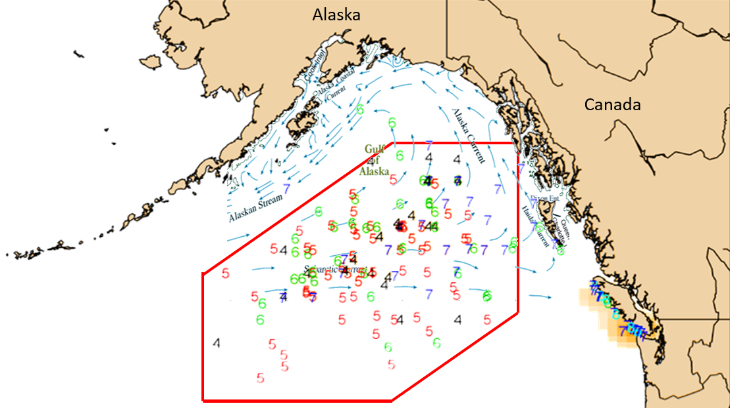

Figure S2. Observed and previously forecast Fraser sockeye adult returns for the 18 major stocks from 2009 to 2020.

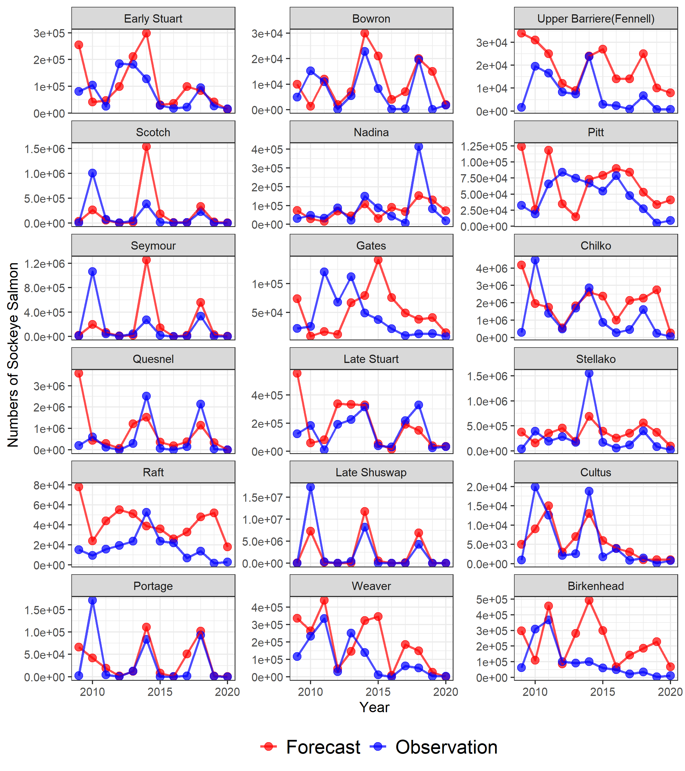

Figure S3. Relative ranking for all 37 models and all 18 Fraser Sockeye stocks of a) absolute value of mean raw error Abs(MRE) b) mean absolute error (MAE) c) absolute value of mean percent error Abs(MPE), d) root-mean-square error (RMSE), and e) normalized forecast metric (NFM) that measures bias with small biases between -2.0 and 2.0 shown numerically.

a.

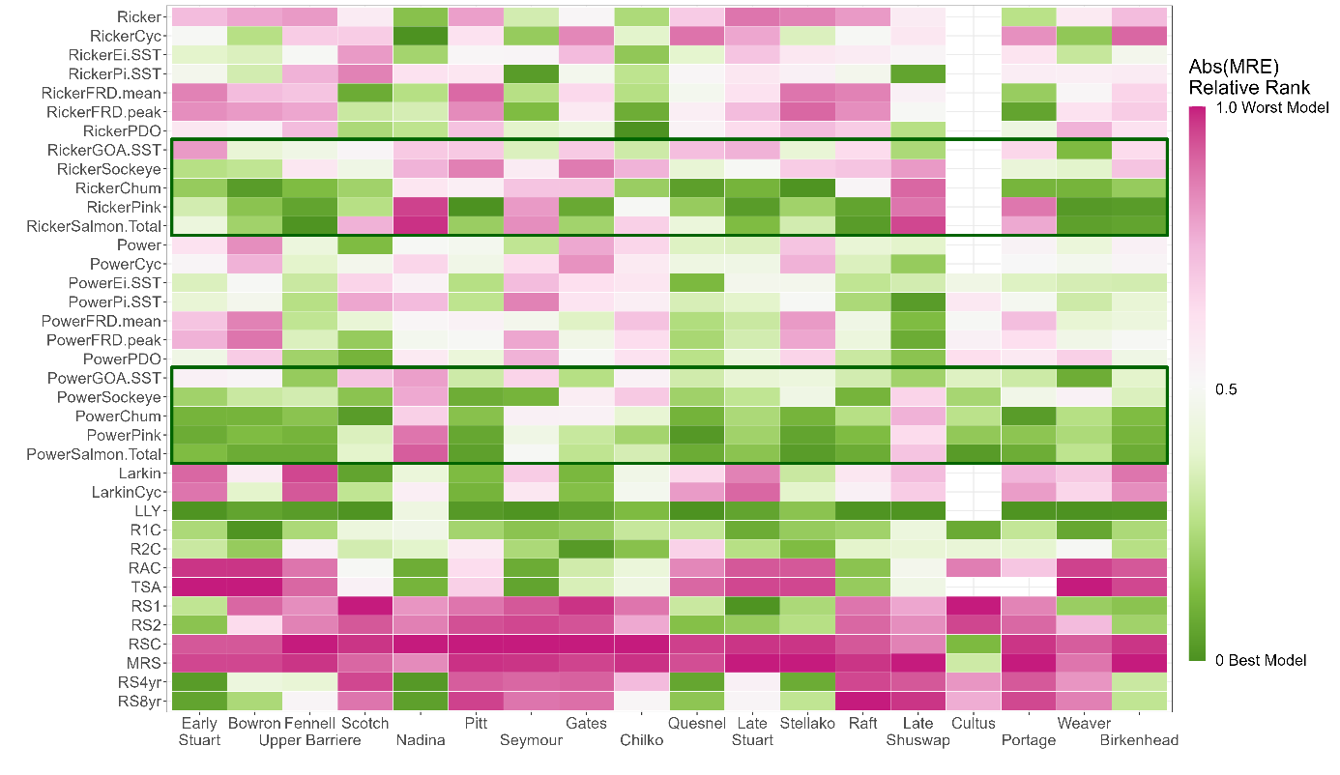

b.

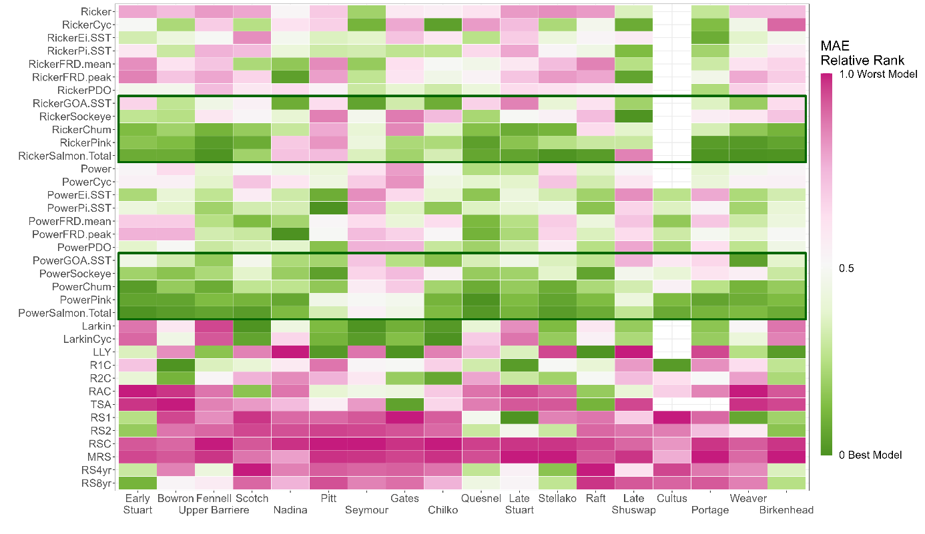

c.

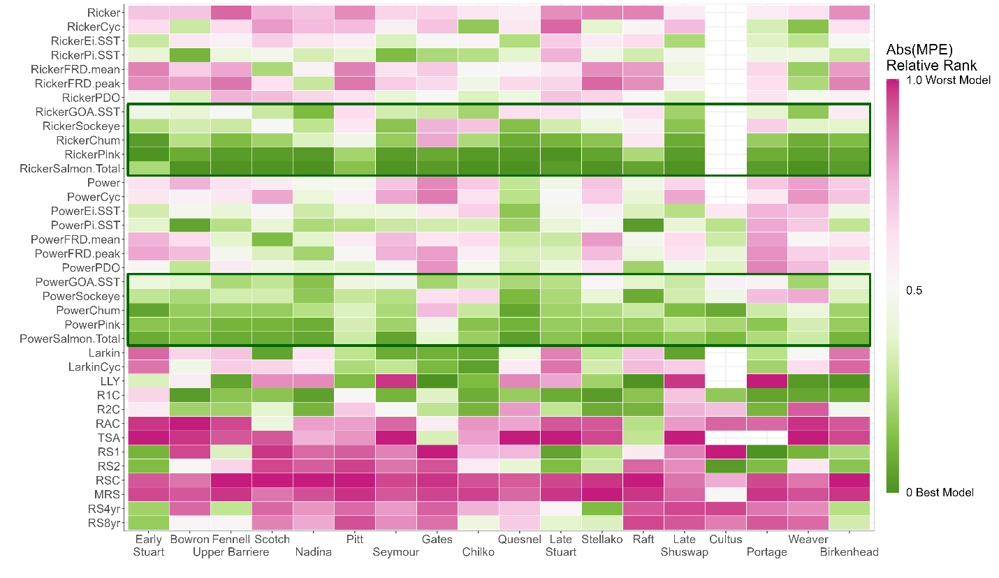

d.

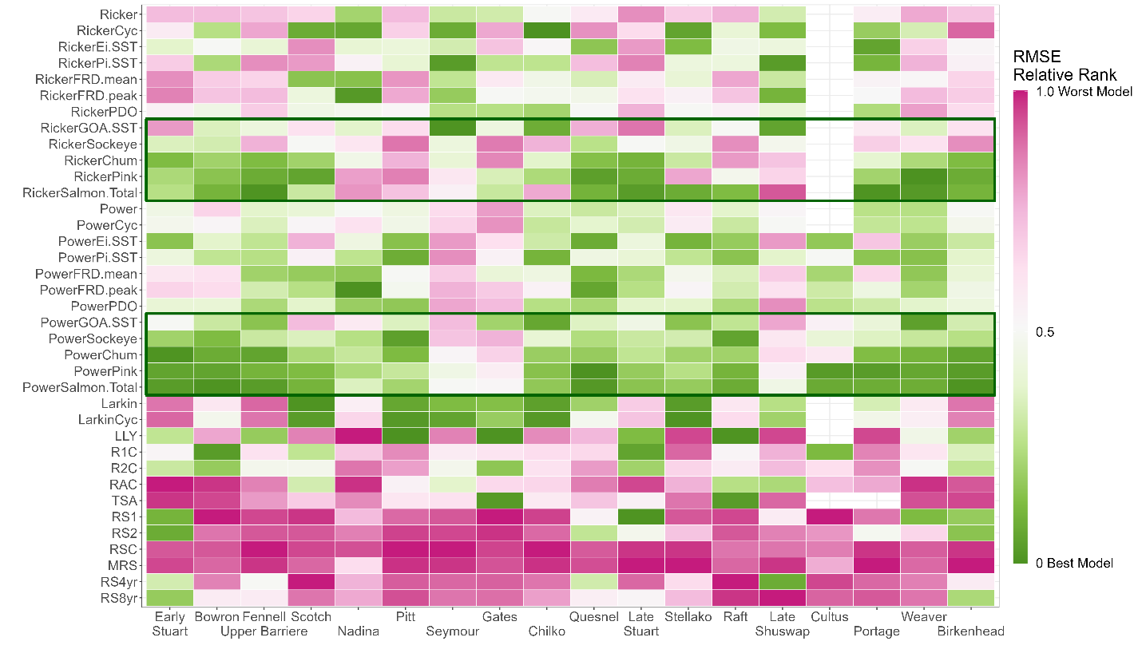

e.

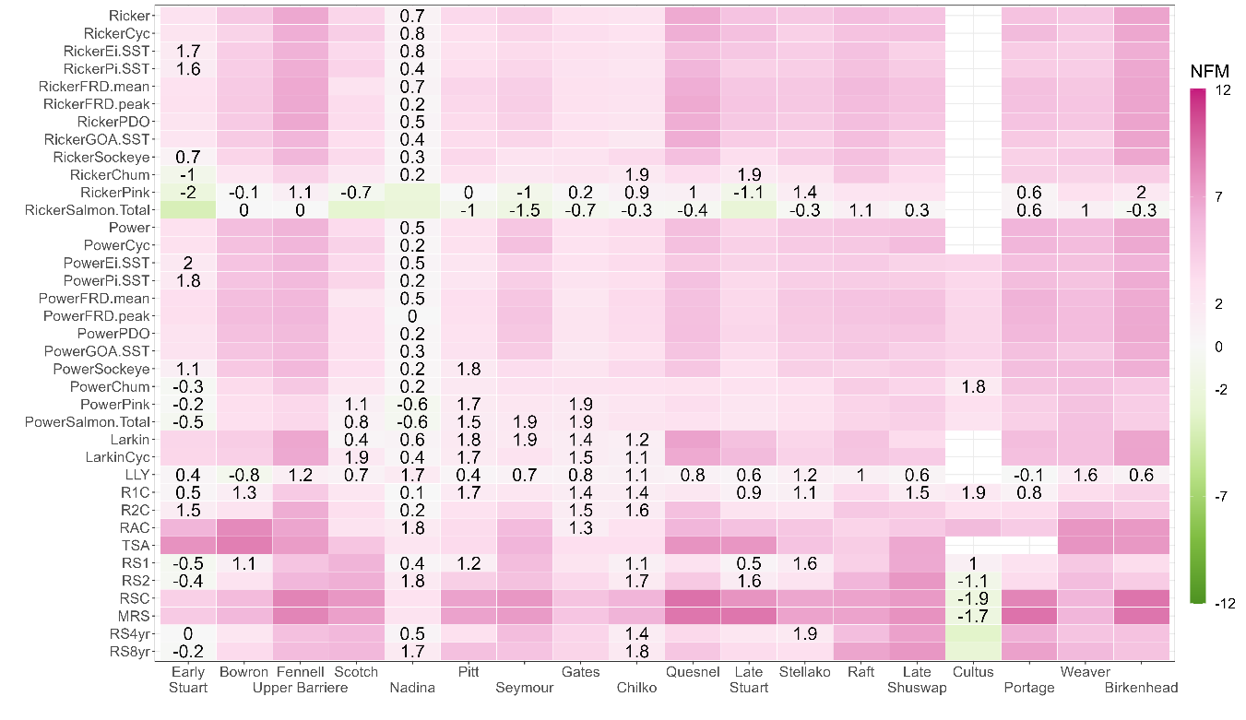

Figure S4. Normalized standard deviation of forecasts from all 37 models along with that from the historically selected model (named Forecast for simplicity) for all 18 Fraser Sockeye stocks during the period of 2009 to 2020.

Figure S5. (a) Age 4 Taylor diagrams for Early Stuart sockeye stock, 7 Early Summer run stocks (Bowron, Fennel (Upper Barriere), Scotch, Nadina, Pitt, Seymour, and Gates), and 1 Summer run stock (Chilko). (b) Age 4 Taylor diagrams for 4 Summer run stocks (Quesnel, Late Stuart, Stellako, Raft) and 5 Late run stocks (Late Shuswap, Cultus, Portage, Weaver, and Birkenhead). Each Taylor diagram compares 37 model forecasts and the historical Forecast (black solid square) against the Observation (black solid circle on the x-axis). The distance from the origin is the normalized standard deviation with the normalized value for observations being 1. The angle describes the correlation between model forecasts and observations. The dashed arcs around the Observation illustrate the root-mean-square error (RMSE). Models with negative correlations are not shown. The closer the model is to the Observation, the better predictive power the model has.

a.

Figure S6. (a) Age 5 Taylor diagrams for Early Stuart Sockeye stock, 7 Early Summer run stocks (Bowron, Fennel (Upper Barriere), Scotch, Nadina, Pitt, Seymour, and Gates), and 1 Summer run stock (Chilko). (b) Age 5 Taylor diagrams for 4 Summer run stocks (Quesnel, Late Stuart, Stellako, Raft) and 5 Late run stocks (Late Shuswap, Cultus, Portage, Weaver, and Birkenhead). Each Taylor diagram compares 38 model forecasts and the historical Forecast (black solid square) against the Observation (black solid circle on the x-axis). The distance from the origin is the normalized standard deviation with the normalized value for observations being 1. The angle describes the correlation between model forecasts and observations. The dashed arcs around the Observation illustrate the root-mean-square error (RMSE). Models with negative correlations are not shown. The closer the model is to the Observation, the better predictive power the model has.

